Copy 1 of 1 copies
HEADQUARTERS
United States Corps of Cadets
United States Military Academy
West Point, New York 10997
15 August 2018

BRIGADE OPORD 2019-02 (MAMI 2019-1)

(U) REFERENCES:

- ADP 5-0 (The Operations Process) 17 May 12
- ATTP 5-0.1 (Commander and Staff Officer Guide) 14 Sep 11
- USCC SOP (Standards of Cadet Living Areas and Standards of Cadet Conduct and Appearance) OCT 17

(U) Time Zone Used Throughout the OPORD: EST

(U) Task Organization: No Change.

- (U) Situation. The Corps of Cadets returned from summer training and leave to reoccupy the barracks which need cleaning, maintenance action, and setup IAW with USCC Cadet SOP. The Brigade MAMI inspection will occur 18 August 2018. The MAMI will include a TA-50 layout, IAW the USCC Cadet SOP.

- (U) Mission. United States Corp of Cadets conducts MAMI inspection at 18 0700-0830AUG18 and a TA-50 layout NLT 18 0830AUG18 IOT ensure cleanliness and serviceability of barracks and equipment so as to set hygienic living conditions and ensure readiness for AY19-1.

- (U) Execution.

- (U) Commander’s Intent. To ensure the Chain of Command documents room and company common area maintenance issues as work orders and that cadets conduct spot corrections on the lowest level, producing a clean environment which is hygienic and safe for living. Inspectors confirm that cadet rooms are IAW AMI standards IOT assure readiness for follow-on AMI inspections.

- (U) Concept of the Operation.

- (U) Phase I- Preparation: Begins with Recall of the Corps // Ends with MAMI initiated.
Cadets prepare personal and public areas for inspection on 18AUG.
- (U) Phase II- BDE MAMI: Begins with MAMI initiated// Ends with MAMI concluded.
Cadets conduct a MAMI at the company level IAW guidance issued in the MAMI checklist, Annex Q Appendix 1, and USCC SOP.
- (U) Phase III- Reconsolidation: Begins with MAMI concluded // Ends with Corps formed for A-Day Parade. Cadets prepare to conduct Acceptance day parade and are formed NLT 0915.

- (U) Tasks to Staff.

- (U) BDE S4. Collect all work orders from the REG S4s IOT ensures that the USCC S4 addresses all of the discrepancies NLT 221900AUG17. POC: CDT Brady Miller, BDE S4, at brady.milller@usma.edu.

- (U) Coordinating Instructions.

- (U) Timeline. See Annex C, Appendix 1.

- (U) Uniform. Army Combat Uniform (UCP/OCP).
- (U) 1st-4th Regiment.

(a) Inspect all levels of leadership.

(b) Hold a MAMI AAR session with REG Staff at the Regimental CDR’s discretion. Submit a final AAR review to Brigade NLT 222330AUG18. POC: CDT Hayden Trainor, BDE S3 at hayden.trainor@usma.edu.

(c) Ensure common areas as well as cadet rooms are to standard IAW USCC Cadet SOP.

(d) Ensure Fourth Class Cadets report to cadet inspectors. All cadets, regardless of rank, will report to active duty commissioned and enlisted personnel when they enter the room. Refer to Annex C, Appendix 2 for reporting procedures.

(e) Display Dog Tags and ID Cards as PAI items on Desk during MAMI Inspection.

(f) TA-50 layouts are conducted NLT 18 0830 AUG 18 with deficiencies notated by the Chain-of-Command. Date and time of the inspection is at the discretion of the Chain-of-Command. Deficient individuals address deficiencies as necessary and are re-inspected by their Chain-of-Command NLT 19 TAPS SEPT 18 IOT ensure readiness for A/C weekend training on 21-22SEPT.

- (U) Key Tasks.

(1) (U) Ensure room cleanliness IAW USCC Cadet SOP.

- (U) Ensure the Chain of Command passes all necessary work orders up to BDE S4 NLT 221600AUG18.

- Ensure al TA-50 is present and serviceable to prepare for AY military training and next year’s CST.

- (U) Endstate. Cadet barracks are clean IAW USCC Cadet SOP to facilitate positive hygiene. All TA-50 deficiencies are identified and plans made to remedy them. Cadets are released IOT prepare for A-day parade NLT 180830AUG17.

- (U) Sustainment.

- None.

5. (U) Command and Signal.

- (U) Command. IAW BDE OPORD 2018-01.

- (U) Control. All first line leadership will be the primary control for subordinate units.

- (U) Signal. IAW Annex C, Appendix 4

ACKNOWLEDGE:

CDT DAVID BINDON
1CPT

OFFICIAL

CDT HAYDEN TRAINOR
S3

ANNEXES:
Annex C - Operations
Appendix 1 - Timeline
Appendix 2 - Reporting Procedures
Appendix 3 - Communications plan
Annex Q – Checklists
Appendix 1 - Room Maintenance Checklist
Appendix 2 - Common Areas Checklist

DISTRIBUTION: S3 OPORD Distro list. via Electronic Email

ANNEX C, APPENDIX 1: Timeline

Time |  | Personnel | Training | Location | Uniform
Start | Finish
180555AUG18 | 0600 | All | Breakfast Formation | BN/CO Areas | ACU’s
0600 | 0630 | All | Breakfast | Mess Hall | ACU’s
0700 | 0830 | All | MAMI | BN/CO Areas | ACU’s
0915 | 1000 | All | A-Day Parade Formation | BN/CO Areas | Sterile W/G Under Arms
1000 | UTC | All | A-Day Parade | Plain | Sterile W/G Under Arms
NLT 211600AUG18 |  | REG S4 | Updated Work Orders to BDE S4 | n/a | n/a

ANNEX C, APPENDIX 2: REPORTING PROCEDURES

CARD 105 – Reporting to an Officer or Noncommissioned Officer 1 Jun 08 USCC SOP Chapter 1 Standards of Conduct and Military Courtesy

1. Indoors:
. Whenever an officer/NCO approaches a table in the Cadet Mess, the table commandant will rise and stand at the position of attention/parade rest to address the officer/NCO. All other cadets at the table may continue eating or talking unless otherwise directed by the officer/NCO.
. Whenever an officer enters a cadet room or common use area, the first cadet to see the officer will call the occupants to attention (e.g. “Group, Attention”). The ranking cadet will then appropriately greet (without saluting) the officer. All cadets will remain at attention until the officer departs or commands otherwise. In the case of a NCO entering a cadet room, cadets follow the same procedures prescribed for an officer, except cadets will command “AT EASE,” and stand at parade rest until otherwise directed by the NCO.
. Cadets who report to an officer's office when not under arms will remove their headgear and any outer garments such as a gray jacket, then knock and enter when told to do so. If there is no place to hang up the headgear or outer garments, they should be carried into the office, tucked under the left arm. After entering the office, cadets approach within two steps of the officer’s desk, halt, salute, and report by saying, "Sir (Ma'am), Cadet _____ reports." If more than one cadet is reporting, the ranking cadet in the group will report for the other cadets as deemed appropriate for the situation. When the business is over, cadets will salute (with an appropriate end greeting, face about and depart the office. In the case of entering a NCO's office, cadets will follow the same procedures prescribed for reporting to an officer's office except there is no hand salute and by saying, "Sergeant/First Sergeant/ Sergeant Major, Cadet______ reports."
. Cadets who report to an officer's office when under arms will follow the same procedures outlined above in paragraph 118a (3) except that they will wear headgear. The rifle will be carried at the trail (ORDER ARMS) and the cadet will render a rifle salute (or if wearing a saber, render a hand salute) to the officer. When reporting under arms to a NCO's office, cadets do not render a salute.
. Whenever the TAC (arrives or departs for the day), the OC, or an officer senior to the TAC enters the cadet barracks, the first cadet seeing the officer will call the company to attention (e.g. “COMPANY, ATTENTION”). The senior cadet present, or CCQ, will then report without saluting to the officer and ask how he/she can help.
. Whenever the TAC NCO (arrives or departs for the day), the NCO OC, or an NCO senior to the TAC NCO enters the cadet barracks, the first cadet seeing the NCO will call “AT EASE.” The senior cadet present, or CCQ, will then report (without saluting) to the NCO and ask how he/she can help.
. When an officer of LTC or higher rank (or CSM) enters the Central Guard Room, the first cadet to see him/her will call the room to attention (or “at ease”) and the senior cadet present will report.

ANNEX C, APPENDIX 3: COMMUNICATIONS PLAN

1CPT
CDT David Bindon
Office – ML1006

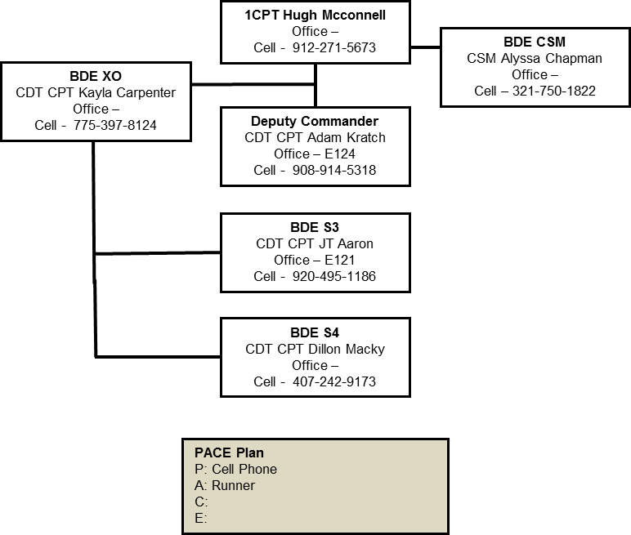
Deputy Commander
CDT Tony Smith
Office – ML1012

BDE XO
CDT Emily Sexaur
Office – ML1007

BDE CSM
CDT Joseph Mannino
Office – ML1006

PAC Plan
P: Cell Phone
A: Runner
C: Command Voice

BDE S3
CDT Hayden Trainor
Office – ML1007

BDE S4
CDT Brady Miller

ANNEX Q, APPENDIX 1: Room Maintenance Checklist

Room Maintenance Checklist
Company______________ Barracks________________ Room Number________________

Location | Status | Comments
Door | Go/ No-Go
Door Lock | Go/ No-Go
Overhead Storage Areas | Go/ No-Go
Wardrobes | Go/ No-Go
Wardrobe drawers | Go/ No-Go
Coat Closet | Go/ No-Go
Weapons Rack | Go/ No-Go
Sink Light | Go/ No-Go
Medicine Cabinet | Go/ No-Go
Sink | Go/ No-Go
Laundry Bins | Go/ No-Go
Towel Racks | Go/ No-Go
Ceiling Lights | Go/ No-Go
Floor | Go/ No-Go
Ceiling | Go/ No-Go
Wall | Go/ No-Go
Desk Lights | Go/ No-Go
Electrical Covers & outlets | Go/ No-Go
Light Switch & Cover | Go/ No-Go
Heater | Go/ No-Go
Window(s) | Go/ No-Go
Window Shades | Go/ No-Go
Other | Go/ No-Go
ANNEX Q, APPENDIX 2: COMMON AREAS CHECKLIST

Common Areas Checklist
Company___________________________
1SG_______________________________

Bathrooms
⇨ All lockers IAW OCT16 BAG
⇨ All drying items on hangers
⇨ Free of trash and debris
⇨ No storage of miscellaneous items
⇨ Work order identity and marked with an index card along with printed work order consolidated at the CCQ

Hallways/ Stairwells
⇨ Clear of trash
⇨ Floors swept
⇨ Clutter free (except DPW supplies and work carts)
⇨ All doors with uniform nametapes
⇨ COC signs displayed
⇨ Display cases, COC tables, etc dusted
⇨ Work order marked with an index card
⇨ Company S4 bulletin board complete in addition to Cadet POC information.

CCQ
⇨ Neat and military in appearance
⇨ All items in the company fridge labeled with name and date
⇨ Sign out book present
⇨ Floors swept and mopped
⇨ Shelves dusted
⇨ Policy Letters Drill Roll present and signed
⇨ No storage of miscellaneous items
⇨ Work order identified and marked with an index card

Study Room
⇨ Neat and military in appearance
⇨ Floors swept and mopped
⇨ Shelves dusted
⇨ No storage of miscellaneous items
⇨ Work order identified and marked with an index card

Trunk Rooms
⇨ Swept/ Free of trash
⇨ Neat and Organized with HVI secured

Inspected by____________________________________________________

